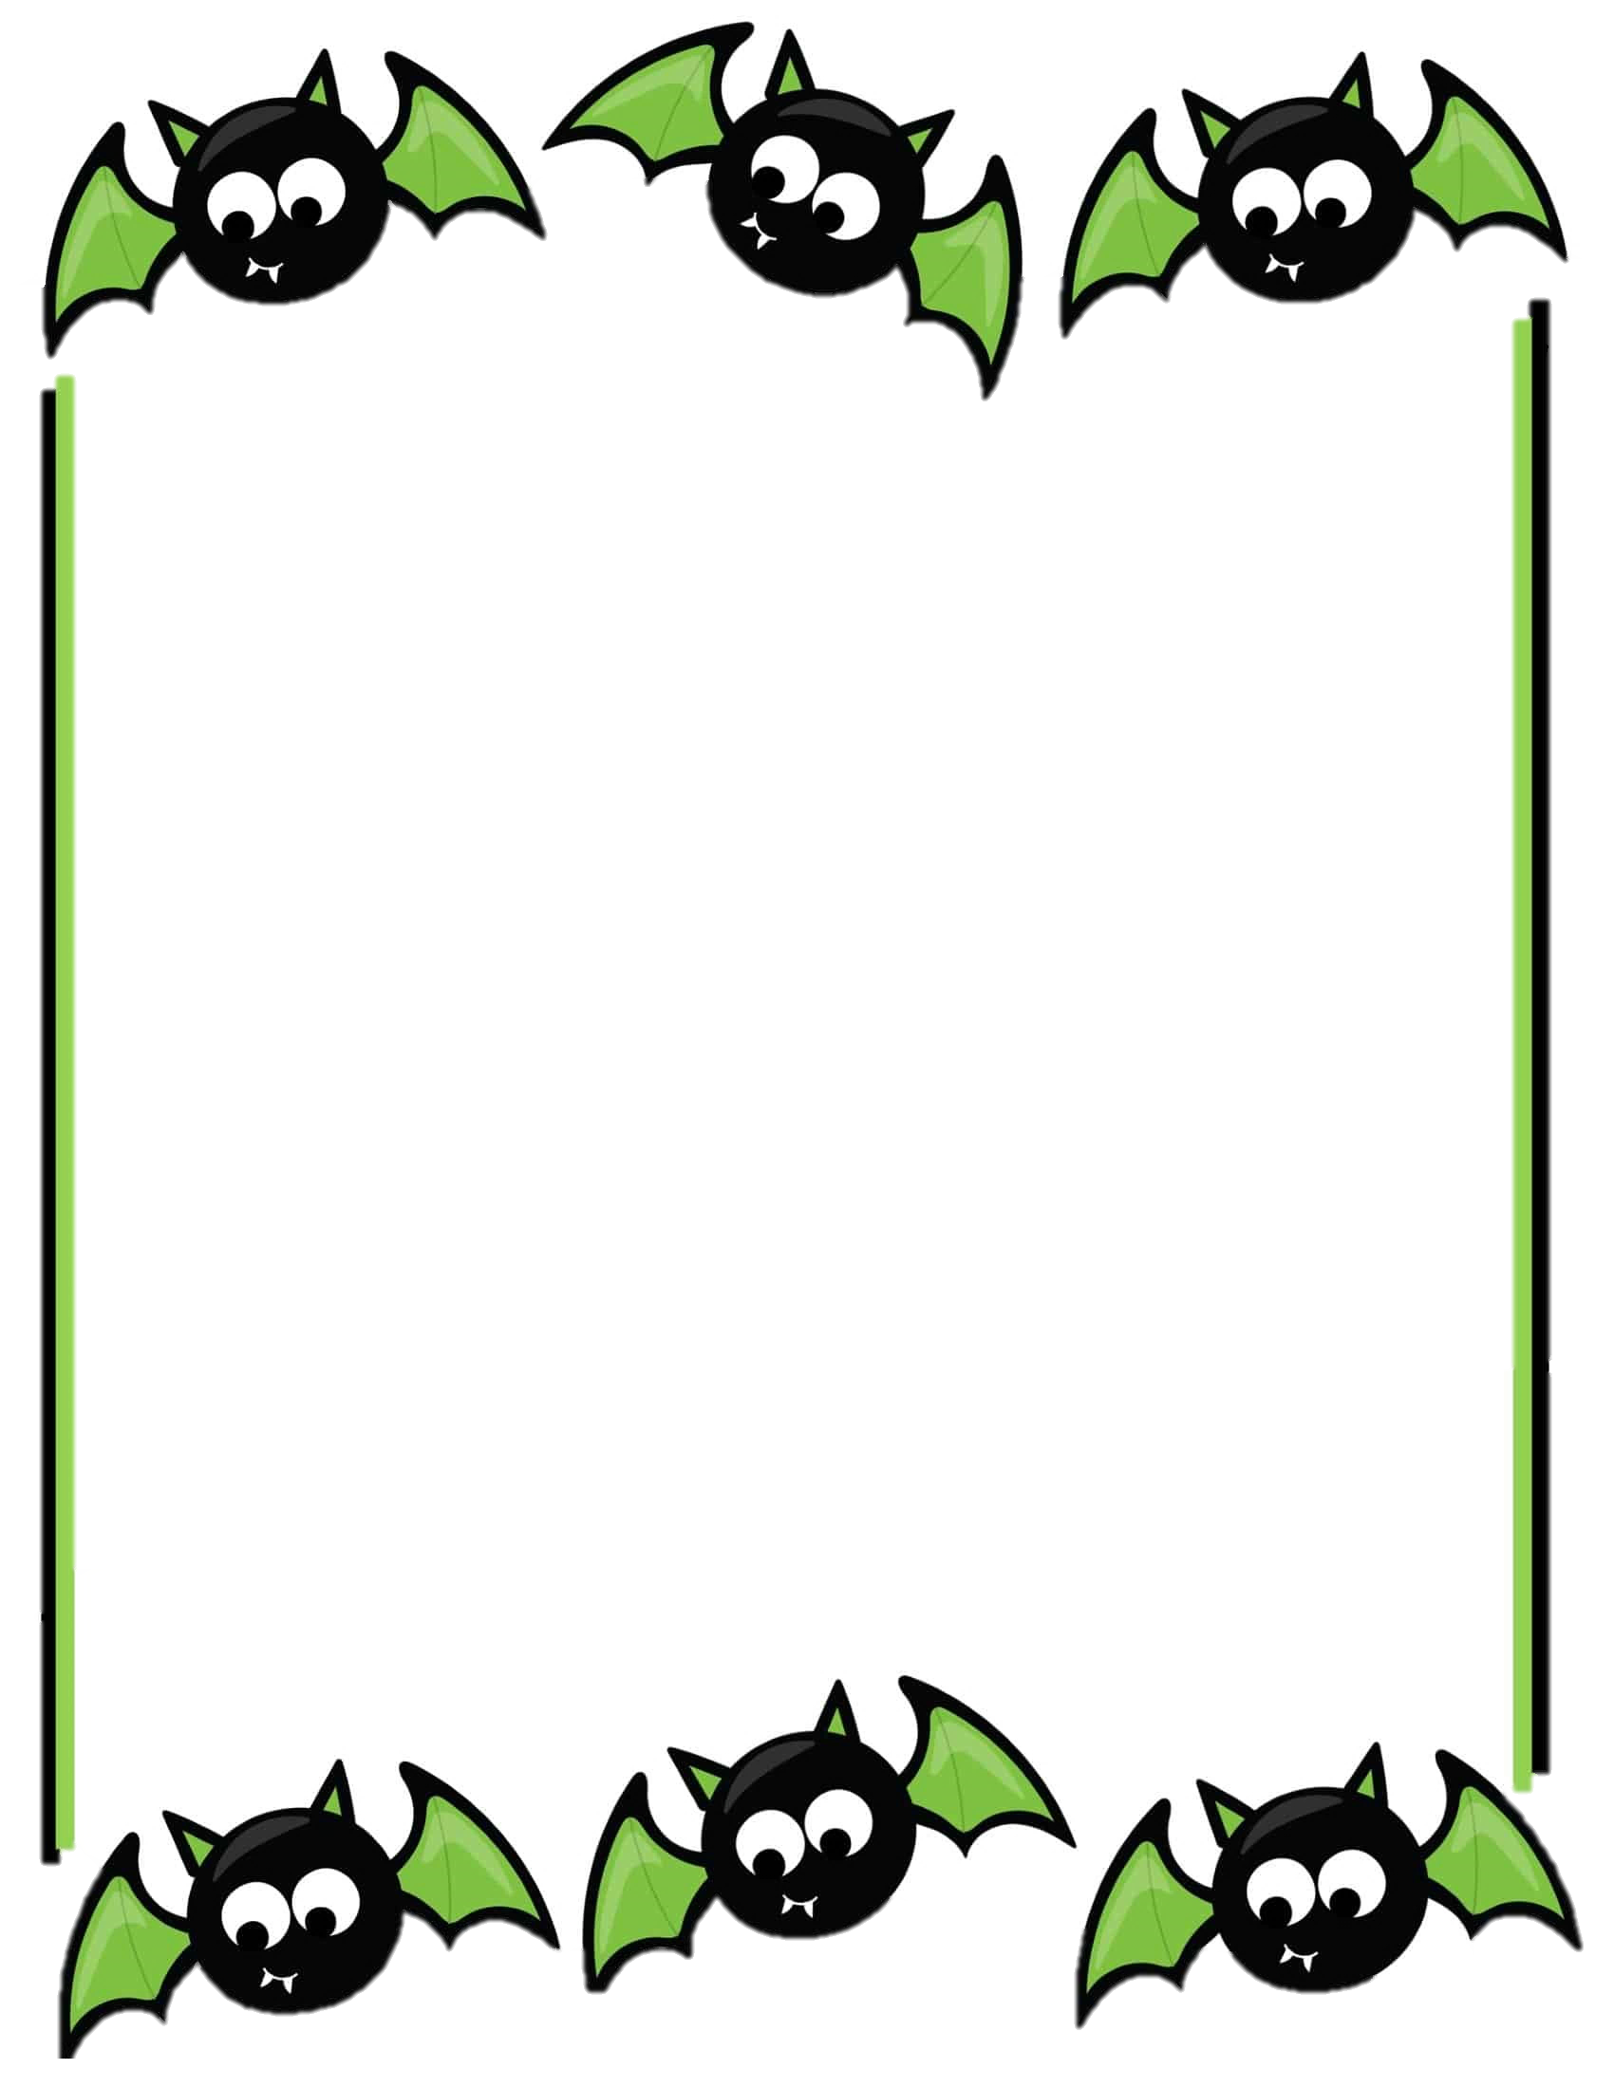

Hello Kindergarten Families

Our Halloween party will be this upcoming Friday, October 31st.
We will be attending Mass in the morning, please have your child come to school in their uniform. Our sweeties will change into their costumes when we return from Mass. For their costumes please nothing scary or witch related. Please do not send any masks. If your child does not want to wear a costume for that day, they are welcome to come in their jeans and Halloween shirt instead. Please have your sweetie bring a bag to collect their sugary treats!

If you would like to send in any goodie bags you are more than welcome. We have 11 friends in our class. We will be celebrating our spooktacular party with our 7th/8th grade buddies! I am looking forward to our fun day, and will be taking/posting lots of pictures!
We will be having an all school Halloween parade that day! You are welcome to join us on our walk during the parade! More details to come from the office soon.

Please let me know if you have any questions,
Ms. Oziem

