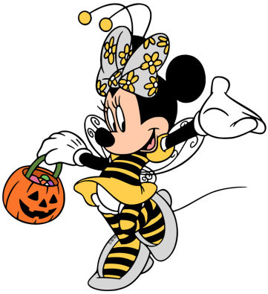
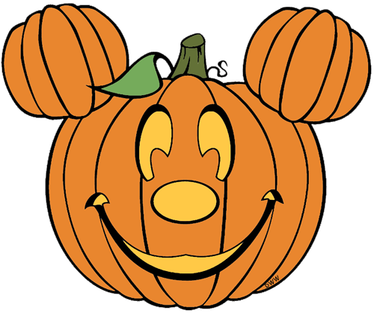


Birthdays
- Happy Feast Day of St. Carlo Acutis (10/12)

Scholastic
- Thank you to everyone who ordered Scholastic this month! Our Scholastic box should be arriving soon! I will send out a Remind when they arrive. Happy Reading!

Mass Days
- All school Mass will be on Thursdays and Fridays.
- Additional days may be added if there is a Holy Day of Obligation/ Feast Day

Homework

- Homework will begin 27th
- Due Friday, October 31st

Classroom Website
- Our classroom website is up and running! Please check our weekly newsletters, homework, pictures inside our classroom, and fun video resources. Our new classroom website is https://ozststephens.wixsite.com/mysite
- Our access code for the pictures is: (click on the tab marked “Inside our classroom”)

Halloween/ Parent-Teacher Conferences/50th day of school
- Our Halloween party will be this upcoming Friday, October 31st.
We will be attending Mass in the morning, please have your child come to school in their uniform. Our sweeties will change into their costumes when we return from Mass. For their costumes please nothing scary or witch related. Please do not send any masks. If your child does not want to wear a costume for that day, they are welcome to come in their jeans and Halloween shirt instead. Please have your sweetie bring a bag to collect their sugary treats! Our Halloween Parade will be at 10:00 am. You are welcome to join us on our walk during the parade!
- Next Thursday - November 6th, will be our Parent/Teacher Conferences. We will have half a day that day. Students will be released by 12 noon, and conferences will begin at 1:15 pm. If you are unable to attend conferences for that day, please let me know and I am happy to set up a conference with you before or after school on another day. I look forward to seeing you soon!
- On Tuesday, November 4th we will be celebrating our 50th Day of School! We will celebrate by having a “dress-up like the 50’s” day. Boys can wear a white t-shirt and jeans (and a jacket if we want to feel like the Fonz ). Girls can wear any type of skirt (like a poodle skirt). Please do not go out and purchase anything. Be creative and use whatever you have at home!

Upcoming Events

- Thursday, October 30th- Jean Day $1 donation
- Friday, October 31st – Halloween Parade/Party with buddies
- Monday, November 3rd- Field Trip Slips and payments due
- Tuesday, November 4th – 50th day of school!
- Thursday, November 6th- Dismissal at noon/Parent Teacher Conferences
- Friday, November 7th- No School

October 27th, 2025

Miss. Oziem’s Classroom Newsletter

HOziem@ststephennb.education

