The Elephant

The Elephant carries a great big trunk;
He never packs it with clothes;
It has no lock and it has no key,
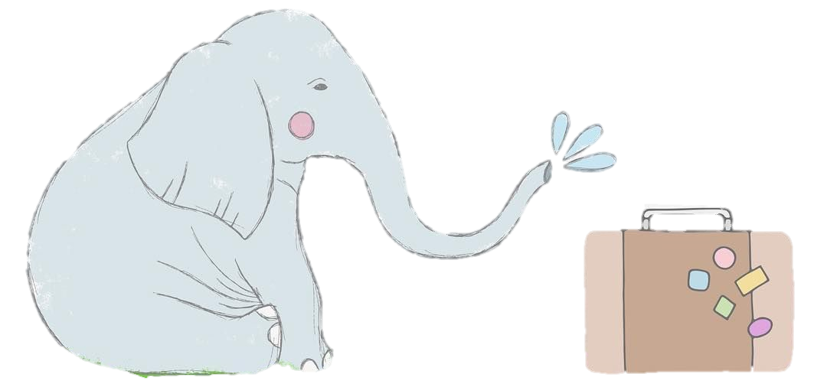
But he takes it wherever it goes.

