An Old Christmas Greeting

Sing hey! Sing hey!
For Christmas Day,
Twine mistletoe and holly,
For friendship glows
In winter snows,
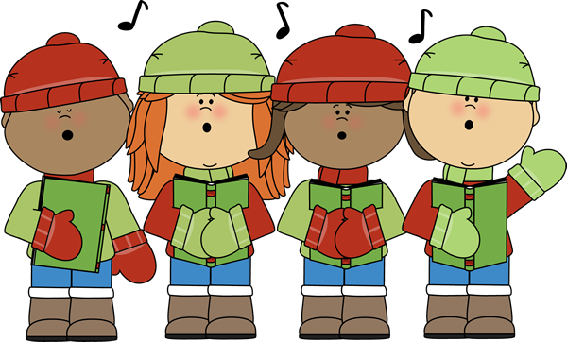
And so let’s all be jolly.

