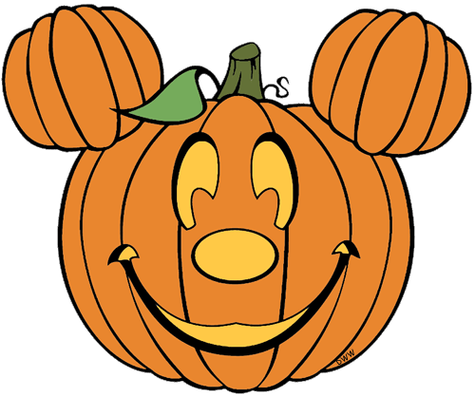


Birthdays
- Happy Feast Day of St. Carlo Acutis (10/12)

Scholastic
- All Scholastic orders are due Friday, October 17th. If you would like to order books, please complete the order form and send in a check payable to Scholastic Reading Club for the correct amount in a labeled envelope. You also have the option of ordering online. Go to https://clubs.scholastic.com/home

Mass Days
- All school Mass will be on Fridays.
- Additional days may be added if there is a Holy Day of Obligation/ Feast Day

Homework

- Homework will begin 20th
- Due Friday, October 24th

Classroom Website
- Our classroom website is up and running! Please check our weekly newsletters, homework, pictures inside our classroom, and fun video resources. Our new classroom website is https://ozststephens.wixsite.com/mysite
- Our access code for the pictures is: (click on the tab marked “Inside our classroom”)

Halloween/ All School Mass/50th day of school
- Today I am sending out a note about our Halloween party. The note will be on the back of this newsletter. I will also be posting it on our website under Newsletters. Please let me know if you have any questions.
- This upcoming Monday and Tuesday, October 27th-28th we will be attending all school Masses for Fr. Zachary’s pilgrimage.
- On Tuesday, November 4th we will be celebrating our 50th Day of School! We will celebrate by having a “dress-up like the 50’s” day. Boys can wear a white t-shirt and jeans (and a jacket if we want to feel like the Fonz ). Girls can wear any type of skirt (like a poodle skirt). Please do not go out and purchase anything. Be creative and use whatever you have at home!

Upcoming Events

- Tuesday, October 21st- End of the 1st Quarter
- Thursday, October 30th- Jean Day $1 donation
- Friday, October 31st – Halloween Parade/Party with buddies
- Monday, November 3rd- Field Trip Slips and payments due
- Tuesday, November 4th – 50th day of school!
- Thursday, November 6th- Dismissal at noon/Parent Teacher Conferences
- Friday, November 7th- No School

October 20th, 2025

Miss. Oziem’s Classroom Newsletter

HOziem@ststephennb.education

