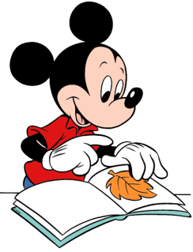
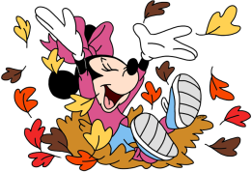

Birthdays
- Happy Birthday to Ryder (9/19)

Scholastic
- Thank you to everyone who ordered Scholastic this month! Our Scholastic box should be arriving soon! I will send out a Remind when they arrive. Happy Reading!

Mass Days
- Thursday and Fridays.
- Additional days may be added if there is a Holy Day of Obligation/ Feast Day

Homework

- Homework will begin September 16th
- Due Friday, September 19th

Classroom Website
- Our classroom website is up and running! Please check our weekly newsletters, homework, pictures inside our classroom, and fun video resources. Our new classroom website is https://ozststephens.wixsite.com/mysite
- Our access code for the pictures is: (click on the tab marked “Inside our classroom”)

Picture Day/ Social Studies Test/Homework update

- As a reminder, picture day is this Friday, September 19th. For their school pictures, the students may wear their Sunday best (dressy clothes), they do not need to wear their school uniform. However, if you would like your child to wear their uniform for the picture, they may. They will wear their dress-up clothes for the rest of the day, and you will not need to send in a spare pair of clothes to change into. (Unless you would prefer too, please let me know). If you have any questions please let me know.
- As we end our Unit 1 on Citizenship, we are preparing to test on all the amazing facts that we have learned! In this week’s homework I have attached a Unit 1 review on the concepts we have learned in this unit. Please review and complete with your child. On Monday 9/22/25, we are going to test our knowledge on these amazing facts! The Unit 1 test will have the same questions as the review given, but with different pictures. This review sheet given will still be turned in with the other homework for homework points. Keep your child’s social studies review sheet until next week so they can go back and review it. Please feel free to ask any question.
- Due to our shorter week this week, we will have our Poetry recitations on Monday, 9/22/25. Please keep your copy of the poem until next week.

Upcoming Events

- Friday, September 19th- Picture Day and Social Studies Unit 1 Test
- Monday, September 22nd –First quarter progress report cards go home
- Monday, September 22nd- Progress Reports go home
- Monday, September 22nd- Unit 1 Social Studies Test

September 15th, 2025

Miss. Oziem’s Classroom Newsletter

HOziem@ststephennb.education

