
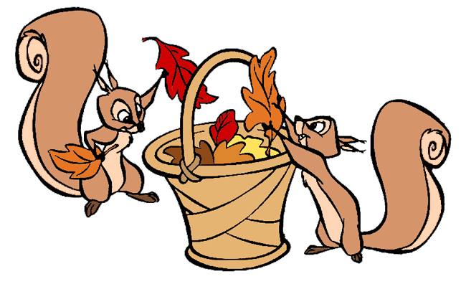

Birthdays
- Happy Birthday to Ryder (9/19)

Scholastic
- Thank you to everyone who ordered Scholastic this month! Our Scholastic box should be arriving soon! I will send out a Remind when they arrive. Happy Reading!

Mass Days
- All school Mass will be on Fridays.
- Additional days may be added if there is a Holy Day of Obligation/ Feast Day

Homework

- Homework will begin September 22nd
- Due Friday, September 26th

Classroom Website
- Our classroom website is up and running! Please check our weekly newsletters, homework, pictures inside our classroom, and fun video resources. Our new classroom website is https://ozststephens.wixsite.com/mysite
- Our access code for the pictures is: (click on the tab marked “Inside our classroom”)

Sight Word Test/ Field Trip

- I am excited to say that Kindergarten is getting ready for our first ever sight word test! This coming Friday the sweeties will take a test to identify their sight words. I will point to each sight word in random order and ask the student to identify the word. This is not a spelling test. They will be asked to identify by sight, not spelling. We will do this test towards the end of each reading unit. A list of our sight words to practice is attached to this week’s homework. Our test will be on Friday, September 26th.
- As a reminder, all field trip slips and payments are due this Friday, September 26th. If your child will not be attending the field trip, please send back the slip marked that your child will not be attending.

Upcoming Events

- Monday, September 22nd –First quarter progress report cards go home
- Monday, September 22nd- Progress Reports go home
- Monday, September 22nd- Unit 1 Social Studies Test
- Friday, September 26th – Sight Word Test/ Field trip slips and payments due

September 22nd, 2025

Miss. Oziem’s Classroom Newsletter

HOziem@ststephennb.education

