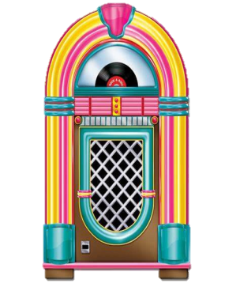
50th day of school parent invite!

Hello Kinder families!

This upcoming Tuesday, November 4th we will be celebrating the 50th day of school!
Parents are more than welcome to come and help in our fun little celebration! We will need some soda jerks (not calling you that, I found that it was the term in the 50s!) for our root beer float station. We will also have a sock hop bingo station, a fun 50s craft station, and will finish our party with a little sock hop dance! We will start our party @2:20 p.m. Please enter through the main entrance, and the office will send you down my way. We would love to see you there! Please send me a message if you are able to come. Thank you for all that you do!



Ms. Oziem

