Thanksgiving Feast

Dear Families,

Next week our Preschool and Kindergarten classes will gather together to partake in our own Thanksgiving Feast! If you are able, please send the item circled below for our feast (every student will have one of the items on the list circled of what they can bring). We will have our feast on Monday, November 24th. Between both grades, we have a total of 26 students. Some items will be split (as mentioned next to the item below) to help with the large amount. Thank you so much for all your help and support!
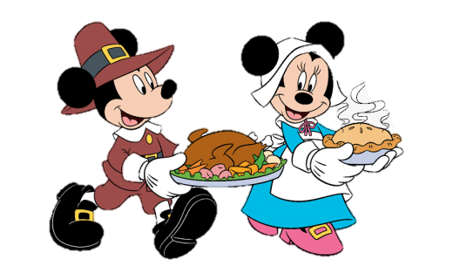
Hugs and Thanks,
Mrs. Knaggs, Mrs. Orris, and Ms. Oziem

- Paper Plates
- Cups
- Napkins
- Forks and spoons
- Milk (1 gallon)
- Apple Juice (1 gallon)
- Deli turkey lunch meat (16 oz)
- Deli ham lunch meat (16 oz)
- Goldfish crackers (1 package)
- Grapes
- Cheese Cubes
- Mashed Potatoes
- Corn
- Matchstick carrots
- Ranch Dip
- Applesauce (1 jar)
- Chips (1 family size bag)
- Pumpkin Pie (1 pie)
- Whipped Cream (bottle or container)
- 1 Table Cloth (from Dollar Tree)

