Ms. Oziem’s Weekly Homework Sheet
HOziem@ststephennb.education
December 8th– December 12th
Monday | Tuesday | Wednesday |  | Thursday | Friday
Reading/ Poetry  * Practice reciting: An Old Christmas Greeting  *Baking Cookies reader (read a little each day, bring back to read Friday)  Reading Log: Please color one Christmas light for each night you read either by yourself or with a helper. Leave this in your homework folder for the whole month and at the end of the month if all of your Christmas lights are colored in, you will get a prize! | Word Families  *Find the words –ot and -op | Sight Words  * Bee, Bee, Bumblebee: my, with |  | Math  * Order Numbers to 12 | * Work on any unfinished work, practice letter sounds, have a wonderful Friday!
December Sight words  come are  me now  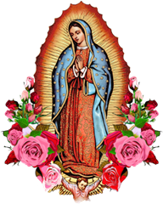  my purple  with orange  you what  said had |  |  | IMPORTANT INFORMATION  *PLEASE SEND A NUTRITIOUS SNACK WITH YOUR CHILD EVERYDAY.  - Monday, December 8th- All School Mass-Feast of the Immaculate Conception  - Wednesday, December 10th - Santa Shop Shopping Day for Kindergarten  - Tuesday, December 16th- Christmas Concert in the gym at 10:00 am./ Christmas cookie party with buddies  - Friday, December 19th- Polar Express Day (date subject to change/will update this week)  Homework due Friday, December 12th

Ms. Oziem’s Weekly Sign Sheet

DATE | PARENT’S SIGNATURE | COMMENTS
Monday, December 8th, 2025
Tuesday, December 9th, 2025
Wednesday, December 10th, 2025
Thursday, December 11th, 2025
Friday, December 12th, 2025
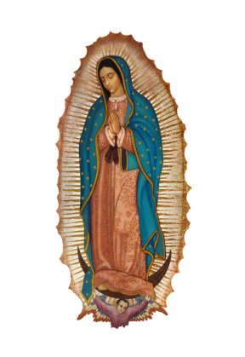
*Please check over your child’s folder daily and sign.
*Please do not tear this out. I will collect it.

