Ms. Oziem’s Weekly Homework Sheet
HOziem@ststephennb.education
November 10th– November 14th
Monday | Tuesday | Wednesday |  | Thursday | Friday
Reading/ Poetry  * Practice reciting: The Pancake  *Dan’s Fat Cat reader (read a little each day, bring back to read Friday)  *Unit 2 Review  Reading Log: Please color one pumpkin for each night you read either by yourself or with a helper. Leave this in your homework folder for the whole month and at the end of the month if all of your pumpkins are colored in, you will get a prize! | Reading/ Social Studies  * Turkey in Disguise (see letter attached in homework for more details and due date)  *Unit 2 Review | Sight Words  * Bee, Bee, Bumblebee: that, pink |  | Math  * Ordinals: First to Fifth  Solanus Casey Center Field Trip | * Work on any unfinished work, practice letter sounds, have a wonderful Friday!
November Sight words  see than  we pink  a yellow  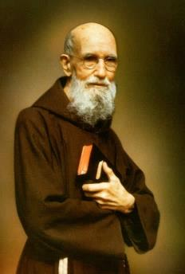  to God  that Jesus  fast |  |  | IMPORTANT INFORMATION  *PLEASE SEND A NUTRITIOUS SNACK WITH YOUR CHILD EVERYDAY.  - Tuesday, November 11th- Veteran’s Day/ All School Mass  - Thursday, November 13th- Solanus Casey Center Field Trip  - Friday, November 14th- Social Studies Test  - Friday, November 21st- Sight Word Test  - Monday, November 24th- Thanksgiving Feast with Preschool  - Tuesday, November 25th- Tom Turkey Project Due  - Wednesday-Friday, November 26th-28th – No School/Thanksgiving Break  Homework due Friday, November 14th

Ms. Oziem’s Weekly Sign Sheet

DATE | PARENT’S SIGNATURE | COMMENTS
Monday, November 10th, 2025 |  | 
Tuesday, November 11th, 2025
Wednesday, November 12th, 2025
Thursday, November 13th, 2025 | Solanus Casey Field Trip
Friday, November 14th, 2025

*Please check over your child’s folder daily and sign.
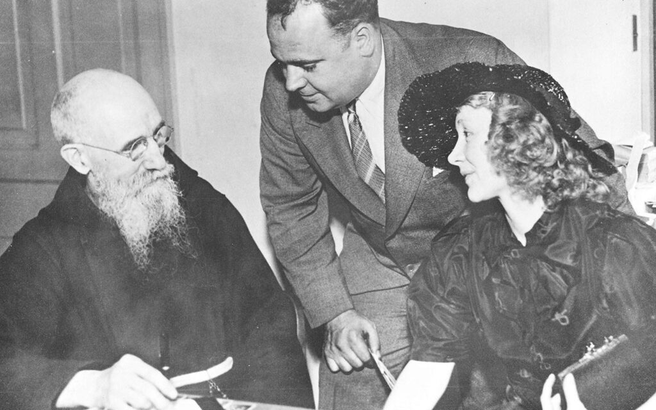
*Please do not tear this out. I will collect it.

