Winter
By: Christina Rossetti

Bread and milk for breakfast,
And woolen frocks to wear,
And a crumb for robin redbreast
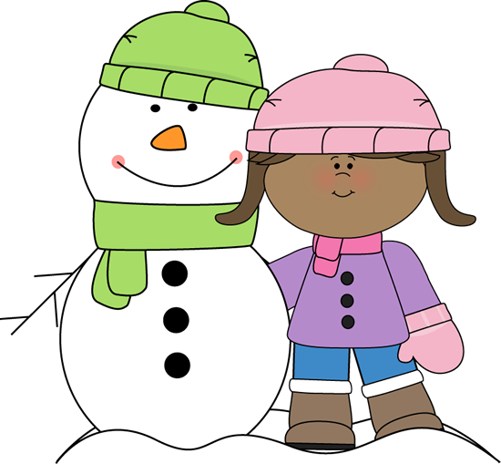
On the cold days of the year.

