The Pancake
By: Christina Rossetti

Mix a pancake,
Stir a pancake,
Pop it in the pan;
Fry the pancake,
Toss the pancake-
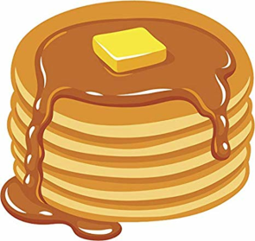
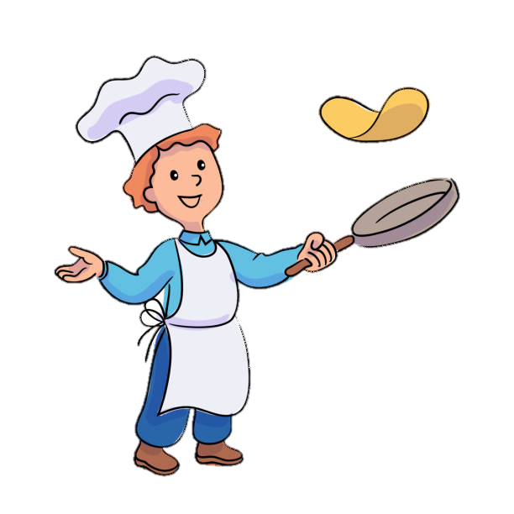
Catch it if you can!

