Ms. Oziem’s Weekly Homework Sheet
HOziem@ststephennb.education
November 17th– November 21st
Monday | Tuesday | Wednesday |  | Thursday | Friday
Reading/ Poetry  * Practice reciting: Turkey Time  *Kim’s Pig reader (read a little each day, bring back to read Friday)  Reading Log: Please color one pumpkin for each night you read either by yourself or with a helper. Leave this in your homework folder for the whole month and at the end of the month if all of your pumpkins are colored in, you will get a prize! | Reading/ Word Families  * Turkey in Disguise (due Tuesday, November 25th)  *Let’s Write with -ip | Sight Words  * Practice for upcoming sight word test |  | Math  * Numbers 1-10 | * Work on any unfinished work, practice letter sounds, have a wonderful Friday!  Sight Word Test!
November Sight words  see than  we pink  a yellow    to God  that Jesus  fast |  |  | IMPORTANT INFORMATION  *PLEASE SEND A NUTRITIOUS SNACK WITH YOUR CHILD EVERYDAY.  - Friday, November 21st- Sight Word Test  - Monday, November 24th- Thanksgiving Feast with Preschool  - Tuesday, November 25th- Tom Turkey Project Due  - Wednesday-Friday, November 26th-28th – No School/Thanksgiving Break  - Monday, December 1st- Grinch Day/ Progress Reports come home  Homework due Friday, November 21st

Ms. Oziem’s Weekly Sign Sheet

DATE | PARENT’S SIGNATURE | COMMENTS
Monday, November 17th, 2025
Tuesday, November 18th, 2025
Wednesday, November 19th, 2025
Thursday, November 20th, 2025
Friday, November 21st, 2025 | Sight Word Test

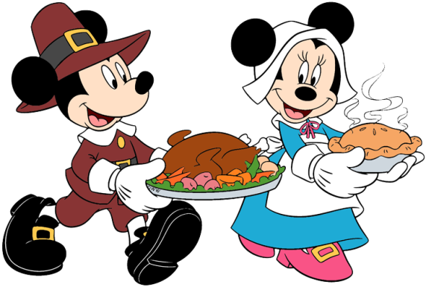
*Please check over your child’s folder daily and sign.
*Please do not tear this out. I will collect it.

