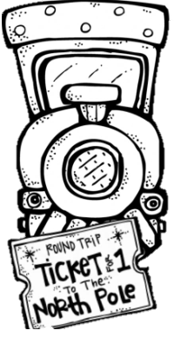
Polar Express Day!

Hello Kinder families!


I am so excited to send out this note for our upcoming Polar Express Day! We will be celebrating our day on Thursday, December 18th. On that day the sweeties may bring in school appropriate pajamas, slippers, and a blanket and stuffy if they would like. We will be attending Mass in the morning, so please have the sweeties come to school in their school uniform, and we will change after Mass. We will be working hard in the morning, and our fun will begin in the afternoon. I will be taking plenty of pictures!

Please let me know if you have any questions,
Ms. Oziem

