

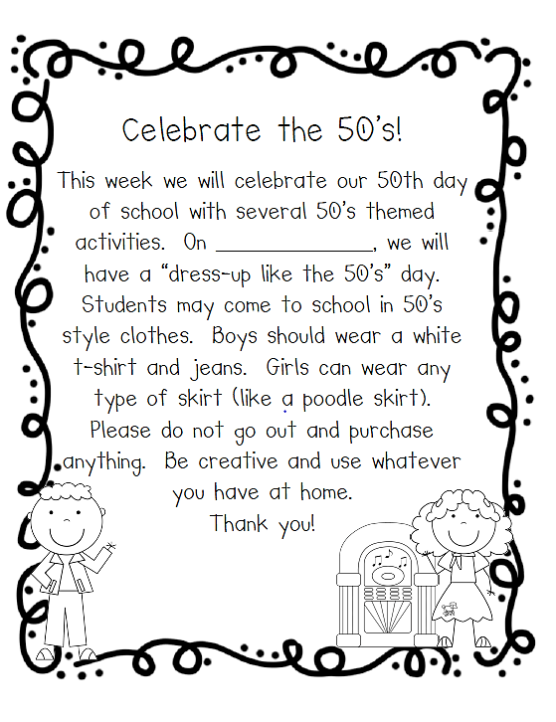
Tuesday, November 4th
Ms. Oziem

We will soon be celebrating our 50th day of school with several 50’s themed activities.
On ___________________, we will have a “dress-up like the 50’s” day.
Students may come to school in the 50’s style clothes. Boys can wear a white t-shirt, jeans, black or letterman jacket, sleek hair, etc. Girls can wear any type of skirt (like a poodle skirt), scarf, ponytail, etc.
Please do not go out and purchase anything. Be creative and use what you have at home.
Hello Kindergarten Family!

