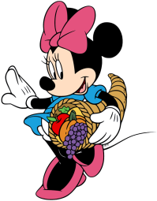
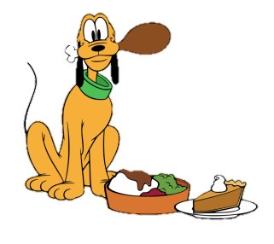
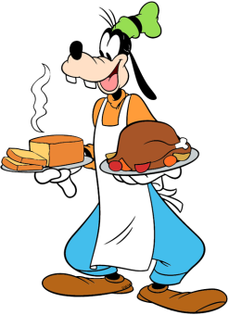

Birthdays
- Happy Birthday to Caden! (11/8)

Scholastic
- All Scholastic orders are due Friday, December 5th. Go to https://clubs.scholastic.com/home and click on the option Connect to teacher. This will prompt you to Find my teacher. Click on our state, and then our school name. It will prompt you to search for your teacher. Click on my name, and then start book hunting!

Mass Days
- All school Mass will be on Thursdays and Fridays.
- Additional days may be added if there is a Holy Day of Obligation/ Feast Day

Homework

- No Homework, Happy Thanksgiving!

Classroom Website
- Our classroom website is up and running! Please check our weekly newsletters, homework, pictures inside our classroom, and fun video resources. Our new classroom website is https://ozststephens.wixsite.com/mysite
- Our access code for the pictures is: (click on the tab marked “Inside our classroom”)

Scholastic/Grinch Day
- We are still waiting for the second half of our catalog to arrive. I will be sending home the first part of the catalog today, and will send the other half when they come in. I apologize for the late delay.
  - All Scholastic orders will be due Friday, December 5th. If any of the books you purchase are planned to be Christmas gifts, please let me know and I can get them to you discreetly.
- This upcoming Monday, December 1st is Grinch Day! Our sweeties can come to school in a green/and or Grinch shirt with their uniform bottoms. A separate note is being sent home as well.

Upcoming Events

- Monday, November 24th- Thanksgiving Feast with Preschool
- Tuesday, November 25th- Tom Turkey Project Due
- Wednesday-Friday, November 26th-28th – No School/Thanksgiving Break
- Monday, December 1st- Grinch Day/ Progress Reports come home

November 24th, 2025

Miss. Oziem’s Classroom Newsletter

HOziem@ststephennb.education

